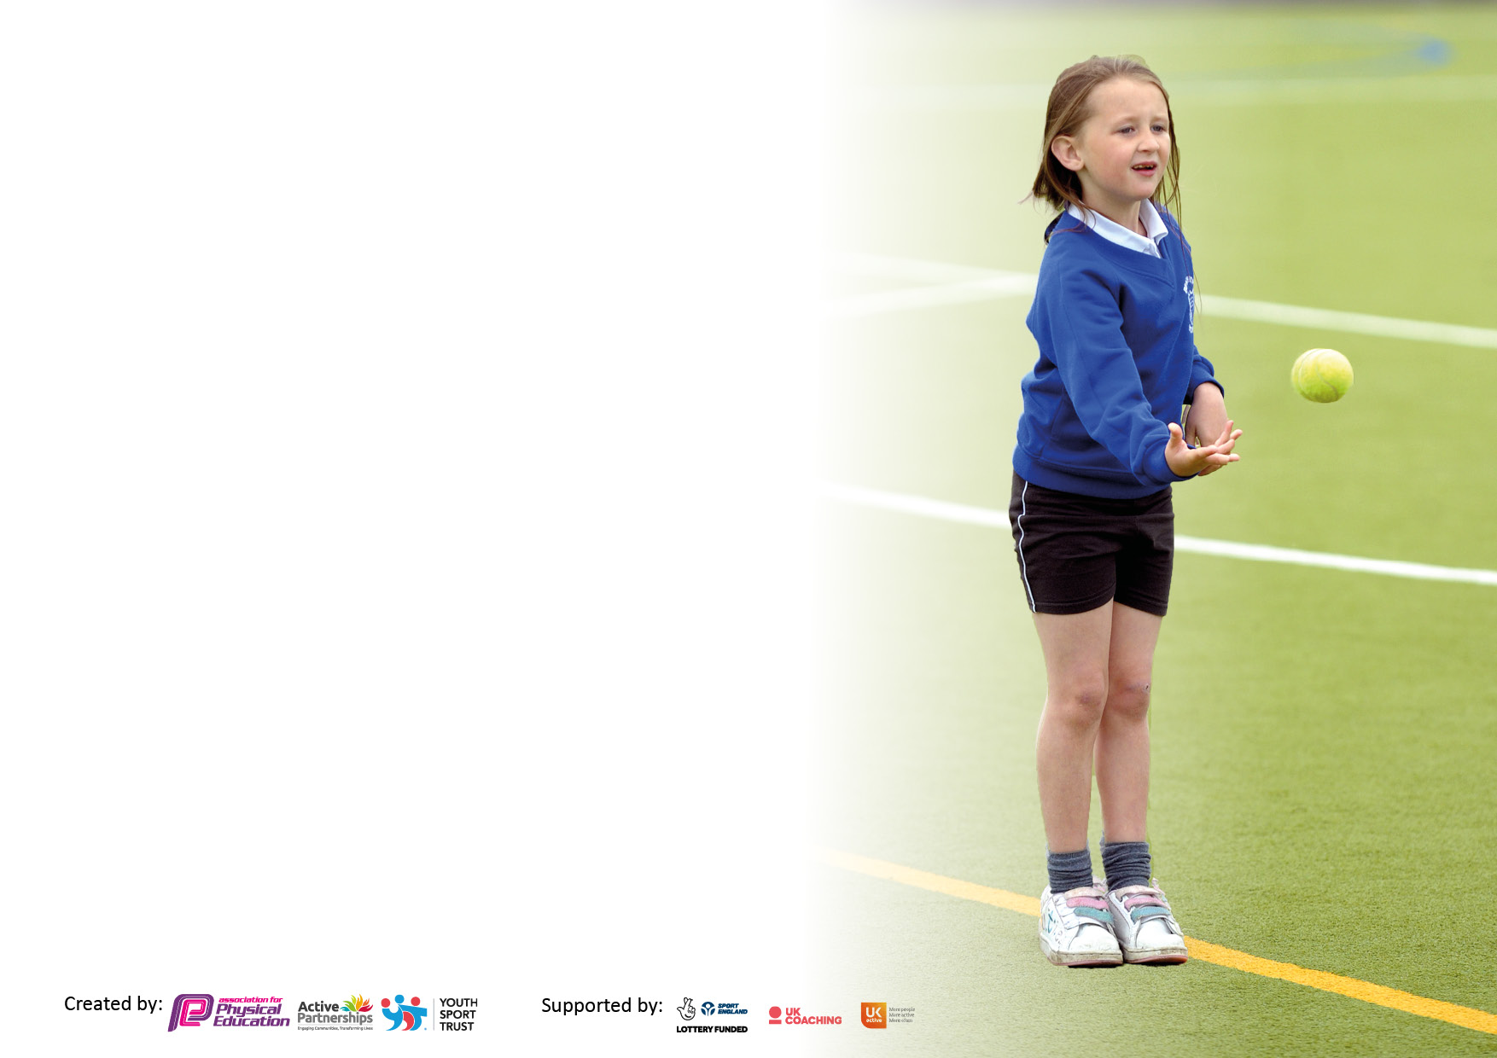

It is important that your grant is used effectively and based on school need. The Education Inspection Framework makes clear there will be a focus on **‘whether leaders and those responsible for governors all understand their respective roles and perform these in a way that enhances the effectiveness of the school’**.

Under the Quality of Education Ofsted inspectors consider:

**Intent** - Curriculum design, coverage and appropriateness

**Implementation** - Curriculum delivery, Teaching (pedagogy) and Assessment

**Impact** - Attainment and progress

To assist schools with common transferable language this template has been developed to utilise the same three headings which should make your plans easily transferable between working documents.

Schools must use the funding to make **additional and sustainable** improvements to the quality of Physical Education, School Sport and Physical Activity (PESSPA) they offer. This means that you should use the Primary PE and sport premium to:

* Develop or add to the PESSPA activities that your school already offer
* Build capacity and capability within the school to ensure that improvements made now will benefit pupils joining the school in future years
* The Primary PE and sport premium should not be used to fund capital spend projects; the school’s budget should fund these.

Pleasevisitgov.ukfortherevisedDfEguidanceincludingthe5keyindicatorsacrosswhichschoolsshoulddemonstrate animprovement.Thisdocumentwillhelpyoutoreviewyourprovisionandtoreportyourspend.DfEencouragesschools to use this template as an effective way of meeting the reporting requirements of the Primary PE and Sport Premium.

We recommend you start by reflecting on the impact of current provision and reviewing the previous spend.

Schools are required to publish details of how they spend this funding, including any under-spend from 2021/2022, as well as on the impact it has on pupils’ PE and sport participation and attainment. **All funding must be spent by 31st July 2023.**

We recommend regularly updating the table and publishing it on your website throughout the year. This evidences your ongoing self-evaluation of how you are using the funding to secure maximum, sustainable impact. Final copy must be posted on your website by the end of the academic year and no later than the 31st July 2023. To see an example of how to complete the table please click HERE.

**Details with regard to funding**

Please complete the table below.

|  |  |
| --- | --- |
| Total amount carried over from 2021/22 | £34,423 |
| Total amount allocated for 2021/22 | £ |
| How much (if any) do you intend to carry over from this total fund into 2022/23? | £ |
| Total amount allocated for 2022/23 | £19,610 |
| Total amount of funding for 2023/23. To be spent and reported on by 31st July 2023. | £ 0 |

**Swimming Data**

Please report on your Swimming Data below.

|  |  |
| --- | --- |
| Meeting national curriculum requirements for swimming and water safety.  N.B. Complete this section to your best ability. For example you might have practised safe self-rescue techniques on dry land which you can then transfer to the pool when school swimming restarts.  **Due to exceptional circumstances priority should be given to ensuring that pupils can perform safe self rescue even if they do not fully meet the first two requirements of the NC programme of study** |  |
| What percentage of your current Year 6 cohort swim competently, confidently and proficiently over a distance of at least 25 metres?  **N.B.** Even though your pupils may swim in another year please report on their attainment on leaving primary school at the end of the summer term 2023.  Please see note above | 85% |
| What percentage of your current Year 6 cohort use a range of strokes effectively [for example, front crawl, backstroke and breaststroke]?  Please see note above | Unknown |
| **What percentage of your current Year 6 cohort perform safe self-rescue in different water-based situations?** | Unknown |
| Schools can choose to use the Primary PE and sport premium to provide additional provision for swimming but this must be for activity **over and above** the national curriculum requirements. Have you used it in this way? | No |

**Action Plan and Budget Tracking**

Capture your intended annual spend against the 5 key indicators. Clarify the success criteria and evidence of impact that you intend to measure to evaluate for pupils today and for the future.

|  |  |  |  |  |
| --- | --- | --- | --- | --- |
| **Academic Year:** 2022/23 | **Total fund allocated: £34,423** | **Date Updated: 30.07.2023** | |  |
| **Key indicator 1:** The engagement of all pupils in regular physical activity – Chief Medical Officers guidelines recommend that primary school pupils undertake at least 30 minutes of physical activity a day in school | | | | Percentage of total allocation: |
| 13% |
| **Intent** | **Implementation** | | **Impact** |  |
| Your school focus should be clear what you want the pupils to know and be able to do and about  what they need to learn and to  consolidate through practice: | Make sure your actions to achieve are linked to your intentions: | Funding allocated: | Evidence of impact: what do pupils now know and what can they now do? What has changed?: | Sustainability and suggested next steps: |
| Dan the Skipping Man | Get children active a break and lunchtime. | £797 | A lot of skipping on the playground. A well-represented skipping show as part of sports day. | An upgrade of skipping ropes as part of the playground resources to maintain popularity. |
| Forest School | Children using the vast outdoor space at the school to be active. | £5870 | Children are now able to use the forest area during their break and lunchtimes and have more knowledge of it to keep them safe and active. |  |
| **Key indicator 2:** The profile of PESSPA being raised across the school as a tool for whole school improvement | | | | Percentage of total allocation: |
| 4% |
| **Intent** | **Implementation** | | **Impact** |  |
| Your school focus should be clear what you want the pupils to know and be able to do and about  what they need to learn and to  consolidate through practice: | Make sure your actions to achieve are linked to your intentions: | Funding allocated: | Evidence of impact: what do pupils now know and what can they now do? What has changed?: | Sustainability and suggested next steps: |
| Sports Leader Conference:   * Pupil/Staff Allocations * Supply Cover * Taxi | To give support to Sports Leaders in delivering provision at break and lunch times. | £200 | Sports Leaders encourage younger children to be active on the playground, leading activities and being responsible for equipment. | Update and introduce new equipment. |
| Playground Resources | To provide children with equipment they can use to be active at break and lunch times. | £300 | Children use and have the option of using a wide variety of equipment at break time and lunch times. |
| Sports Leader Hoodies | To make Sports Leaders easily identifiable and allow them to take ownership of their responsibility. | £1,346 | Children are easily identifiable by younger children and represent a person or place children know they can go to be active. | Buy similar tops for next year’s sports leaders. |
| Play Leader Hoodies | To make Sports Leaders easily identifiable and allow them to take ownership of their responsibility. | Children are easily identifiable by younger children and represent a person or place children know they can go to be active. | Train new play leaders next year to wear the play leader tops. |
| New Girls Football Kit | To raise the profile of girls football across the school. | A new kit has been chosen by children and bought and will be unveiled by the girls at the girls football tournament in Warminster next term. | N/A |

|  |  |  |  |  |
| --- | --- | --- | --- | --- |
| **Key indicator 3:** Increased confidence, knowledge and skills of all staff in teaching PE and sport | | | | Percentage of total allocation: |
| 45% |
| **Intent** | **Implementation** | | **Impact** |  |
| Your school focus should be clear | Make sure your actions to | Funding | Evidence of impact: what do | Sustainability and suggested |
| what you want the pupils to know | achieve are linked to your | allocated: | pupils now know and what | next steps: |
| and be able to do and about | intentions: |  | can they now do? What has |  |
| what they need to learn and to |  |  | changed?: |  |
| consolidate through practice: |  |  |  |  |
| Cluster Sports Specialist | To give CPD to newer members of staff.  To provide more varied curriculum opportunities for the cluster. | £6000 | Children have been given wider opportunities with sports such as Tri Golf, Dodgeball and Frisbee. | To increase the amount of tournaments played within the cluster involving wider reaching sports. |
| Renewal of the Get Set 4 PE Scheme | To allow the continued use of the Get Set 4 PE scheme. | £550 | Staff continue to use the Get Set 4 PE scheme and develop the teaching of it. | Make use of the added features of the scheme. |
| Purchasing Resource Storage Facilities | To allow better storage and access of equipment for staff and sports leaders. | £3,649 | There is more space for equipment. | Create expectations and clear instructions for staff and leaders to keep equipment in an orderly fashion. |
| Upgrading of PE Equipment | To ensure ALL equipment needed for the Get Set 4 PE scheme is available for teachers to deliver it. | £12,560 | All equipment id available for teachers to deliver the scheme. |
| **Key indicator 4:** Broader experience of a range of sports and activities offered to all pupils | | | | Percentage of total allocation: |
| 36% |
| **Intent** | **Implementation** | | **Impact** |  |
| Your school focus should be clear | Make sure your actions to | Funding | Evidence of impact: what do | Sustainability and suggested |
| what you want the pupils to know | achieve are linked to your | allocated: | pupils now know and what | next steps: |
| and be able to do and about | intentions: |  | can they now do? What has |  |
| what they need to learn and to |  |  | changed?: |  |
| consolidate through practice: |  |  |  |  |
| Additional achievements: |  | £ |  |  |
| Top up of resources | A variety of sports equipment to give children a broad experience of an increased amount of activities and games. | £5,000 | The school has now (a year in) begun to offer a wider range of sports for children, in keeping with the skills progression framework on the Get Set 4 PE scheme. | Keep on the lookout for other sports that could be integrated into the curriculum and ensure children progress across their time at Christ Church. |
| Blue-Sky Tennis | A professional coach to come and teach children skills and in turn give CPD opportunities to staff. | £12,963 | An LTA graded coach has taught key skills that children can build on. Staff have also seen demonstrations and activities that can further enhance that used in the Get Set 4PE scheme. | Get the same coach company in to offer teaching further down the school. |
| Premier Sports |
| Supply Cover | To allow staff to take teams of children to competitions against other schools. | £300 | Various children have been given opportunities to compete in a wide range of sports including: football, cricket, dodgeball, athletics and tag rugby. |  |

|  |  |  |  |  |
| --- | --- | --- | --- | --- |
| **Key indicator 5:** Increased participation in competitive sport | | | | Percentage of total allocation: |
| 1% |
| **Intent** | **Implementation** | | **Impact** |  |
| Your school focus should be clear | Make sure your actions to | Funding | Evidence of impact: what do | Sustainability and suggested |
| what you want the pupils to know | achieve are linked to your | allocated: | pupils now know and what | next steps: |
| and be able to do and about | intentions: |  | can they now do? What has |  |
| what they need to learn and to |  |  | changed?: |  |
| consolidate through practice: |  |  |  |  |
| Quad Kids at Bath University | To give children an opportunity to compete in sports outside of school. This will further enhance the skills learned in the PE Scheme and help shape a passion for sport and activity. | Coach costs:  £420  Supply Cover:  £300 | Children in Year 6 will go on to secondary school with added knowledge of what it takes to compete in competitions.  Children in Year 5 will be able to use their informed knowledge of competition to better compete next year. | Enter more competitions and set up more cluster competitions in a variety of sport. |
| Dynamos Cricket at Winsley Cricket Club |
| Tag Rugby Festival at Trowbridge Rugby Club |
| Mixed Football Tournament at Kingdown School |
| Dodgeball Tournament at St. Laurence School |
| Dance Festival at the Forum, Bath |

|  |  |
| --- | --- |
| Signed off by | |
| Head Teacher: | Susan Tudge |
| Date: | 30th July 2023 |
| Subject Leader: | Mark Birleson |
| Date: | 30th July 2023 |
| Governor: | Graham Adams |
| Date: | 30th July 2023 |