Year 2: Long term Overview
 | Term 1  6 weeks 3 days  Farm to Fork | Term 2  7 weeks 3 days  Panic in Pudding Lane | Term 3  5 weeks 2 days  Frozen Planet | Term 4  5 weeks 4 days  Journeys |  | Term 5  6 weeks  If I had a pet dragon… | Term 6  7 weeks 3 days  How does Kampong Ayer compare with where I live?
Maths | Numbers 10 to 100  Calculations within 20 | Introduction to multiplication | Addition and subtraction of two-digit numbers (1)  Introduction to division structures  Shape | Addition and subtraction of two-digit numbers (2)  Money  Fractions |  | Time  Position and direction | Multiplication and division – doubling, halving, quotitive and partitive division  Sense of measure – capacity, volume, mass
Writing | Information – poster for the missing disgusting sandwich  Instructions- How to make the World’s most disgusting sandwich  Narrative 1 – Innovate The Disgusting Sandwich | Setting description – great fire of London setting  Recount – GFOL experiential day | Non- chronological report 1- Emperor penguins  Poetry – Dinnertime by Michael Rosen (link to writing based on Leaf) | Narrative 2 – write own version of Grandad and granddaughter going on a journey/adventure  Letter – from Floella Benjamin describing her journey to England  Character description- Description of Grandad |  | Non- chronological report 2- own invented dragon.  Diary- day in the life of looking after a dragon | Setting description- Rainforest  Narrative 3 – innovated story based on inspiration text  Explanation- linked to plants in science  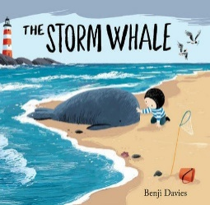  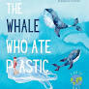
Inspirational Texts | 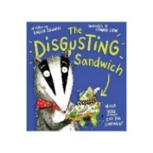 | 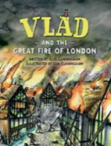  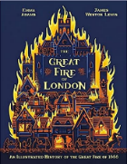 | 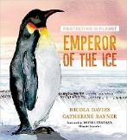 |   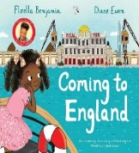 |  | 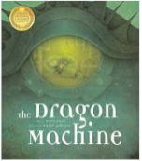 | 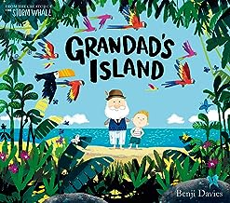
Phonics/Spelling | Little Wandle Phase 5 Review | Little Wandle Y2 Bridge to spelling | Little Wandle Y2 Spelling Units | Little Wandle Y2 Spelling Units |  | Little Wandle Y2 Spelling Units | Little Wandle Y2 Spelling Units
Reading | Little Wandle Reading Sessions | Little Wandle Reading Sessions | Whole class guided reading:  Fiction Emperor of the ice  Non Fiction: The Emperor’s Egg  Poetry (Humorous with pattern and rhyme): Michael Rosen ‘Don’t or ‘I Don’t like custard |  | Whole class guided reading:  Fiction (culturally diverse): Coming to England or The water princess b Susan Verde  Non Fiction: The water ptincess b Susan Verde- information pages about water at the back of book page spread.  Poetry (pattern and rhyme) – The owl and the pussy cat | Whole class Guided reading:  Fiction (Quest and adventure stories): The Dragon Machine  Non Fiction: The big book of blooms  Poetry (about the senses) | Whole class guided reading:  Fiction (traditional tales from other cultures):  Little Red and the very Hungry Lion. The Ghanaian Goldilocks/  Non Fiction- A place called Home by Kate Baker
Class Reading Book | First two weeks-promote books from the book corner/Model how to choose books from the book corner/how to use it.  George’s Marvellous | First week back promote new books from the book corner.  Picture books by Alex T Smith  When Winston delivered Christmas by Alex T smith | First week back promote new books from the book corner.  Einstein The Penguin |  | First week back promote new books from the book corner.  Daisy and the Trouble with Chocolate | First week back promote new books from the book corner.  The Boy Who Grew Dragons | First week back promote new books from the book corner.  Hotel Flamingo
Handwriting | Penpals  Descenders – j y p g q f  Ascenders – l, t, b, h, k, d, f  Trunk letters – u, i, r, n. m. c, a, o s e. z, v, w, x | Penpals  Descenders – j y p g q f  Ascenders – l, t, b, h, k, d, f  Trunk letters – u, i, r, n. m. c, a, o s e. z, v, w, x | Begin Penpals – 1.2,  Units 11 - 20  Introduce diagonal joins to ascender – at, all, th, ch, cl,  Introducing diagonal join, no ascender – cr, tr, dr, lp, mp  Introducing diagonal join, no ascender, to an anticlockwise letter – id, ig, nd, ld, ng |  | Penpals 1.3, units 21 – 30  Practising diagonal join, no ascender - ee, ai,ay, ime, ine.  Introducing horizontal join, no ascender – one, ome  Introducing horizontal join, no ascender, to an anticlockwise letter – oa, og, wa, wo,  Introducing horizontal join to ascender – ol, ot, wh, oh,  Introducing horizontal and diagonal joins, to ascenders, to an anticlockwise letter – of, if | Penpals 2.1 planning units 1-10  How to join in a word, introducing the break letters – j, g, x, y, z, b, f, p, q, r, s  Practising horizontal join to ascender in words – eel, eet  Practising diagonal join, no ascender in words – a_e  Practising diagonal join, no ascender, to an anticlockwise letter in words – ice, ide  Practising horizontal join, no ascender in words ow, ou, oy, oi,  Practising horizontal join, no ascender to an anticlockwise letter in words 0 oa, ode  Practising horizontal join to ascender in words ole, obe, ook, ool | Penpals 2.2, units 11 -20  Diagonal join to r – ir, ur, er  Horizontal join to r – or, oor  Introducing horizontal join from r to ascender url, irl, irt  Horizontal join from r – ere  Joining from r – air  Diagonal join to s – dis  Horizontal join to s – ws  Diagonal join from s to ascender – sh  Diagonal join from s, no ascender - si, su, se, sp, sm  Horizontal join from r to an anticlockwise letter rs.
Science | Living things and their habitats – visit habitats throughout the year  Plants (growing seeds and bulbs outside) – visit planting areas frequently throughout the year to observe
 | Living things and their  habitats | Uses of everyday  materials (properties  and uses of materials) | Animals, including  humans | Animals, including  humans |  | Plants | Plants
Art & Design | Drawing  Experiment with line, space, tone and shape.  Drawing focus…  Drawing focus…Illustration.  Illustrators  Daniel Mackie is an award-winning illustrator  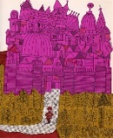  Fran Preston Gannon  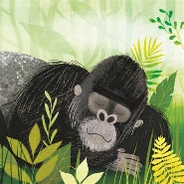  Zairia Forman…pastel drawings.   | Painting  Mix a range of secondary colours.  GFoL painting  Artists and colour.  Claude Monet  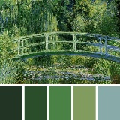  Van Gogh  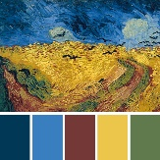  Helen Frankenthaler  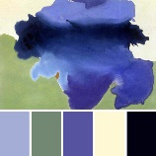  Georgia O’Keeffe   | Printing  Using manmade objects to create ordered patterns.  Print on paper and fabric.  Artist Focus:  Indian printing blocks.  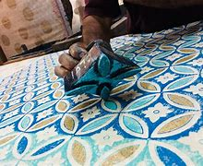 | Collage  Use a range of papers to create images.  Artist Focus: Brianna McCarthy  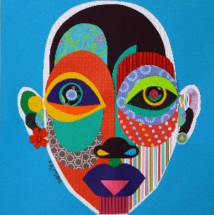 |  | Clay  Flat clay plaque – dragon eyes  Artist Focus:  Nancy McCroskey  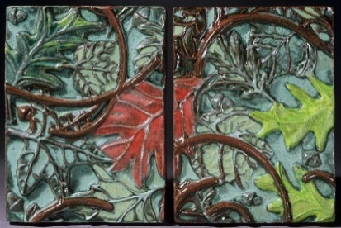 | Textiles Use a range of stitches to embellish or join materials.  Linked to DT  Pouches  Selecting and cutting material for sewing.  If doing this unit through DT then there will need to be some reference to an artist using collage.  Jenny Douglass  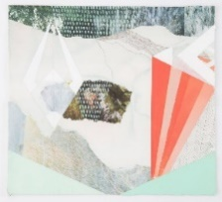  Deborah Collum  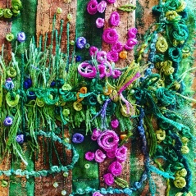
Computing | Coding and Debugging 2 | Making Pictures 2 | Telling Stories 2 (link to narrative) | Technology in and out of school 2 |  | Word Processing 2 | Taking Videos (to show children in Kapong Ayer our school)
Design and Technology | Food: a balanced diet. | Mechanisms: Fairground wheel. |  | Structures: baby bear’s chair. |  | Mechanisms: moving monsters. | Textiles: pouches.
Geography | Why does it matter where our food comes from? |  | Why don’t penguins need to fly? |  |  |  | How does Kampong Ayer compare with where I live?  (small area in a contrasting non-European country)
History |  | Great Fire of London  What happened to London during the fire of 1666? |  | key historical figures  Floella Benjamin
French | Les formes | Noël | Je Peux | Les legumes |  | Les glaces | Le transport
Music | ‘Carnival of the Animals’ | ‘Performing Together | ‘Dragon Dance’ | ‘Silver Spider’ |  | ‘Brown Bear, Brown Bear, What Do You See?’ | 1st Access Recorders 1
 | Consolidate and Practice Ta & Ti Ti, So and Mi.  Exploration of how Music can create an effect. | Prepare and Present Duple Metre  Topic related and Christmas performances, to include adding a rhythmic / simple tuned ostinato  Tuned Perucssion - So, Mi | Prepare and Present ta rest  Tuned Percussion:- So, Mi  Performing and composing ostinatos. | Prepare and Present La  Tuned Percussion - So, Mi, La  Composing in response to a stimuli. |  | Consolidate and Practice Ta & Ti Ti, So, Mi and La  Tuned Percussion - So, Mi, La | Introduction to the recorder  B & A  Too Repertoire
 | Repertoire will be linked to topic work and calendar events as relevant. Ongoing practice of known rhythms and pitches will continue throughout the year. All units will include elements of singing, playing instruments, composing, listening and understanding.
PE | Team Building  Fundamentals | Gymnastics  Mindful Stretching | Fitness  Ball Skills | Sending and Receiving  Dance |  | Invasion  Target Games | Athletics  Striking and Fielding
Religion and Worldviews | Worldview: Christianity  What do Christians believe God is like?  UC: God | Worldview: Christianity  Why does Christmas matter to Christians? UC: Incarnation Digging Deeper | Worldview: Judaism  How important is it for Jewish people to do what God asks them to do?  Discovery RE | Worldview: Christianity  What is the good news Jesus brings?  UC: Gospel |  | Worldview: Judaism  How special is the relationship Jews have with God?  Discovery RE | Worldview: Judaism  What is the best way for a Jew to show commitment to God?  Discovery RE
PSHE | Being Me in My World | Celebrating Difference | Dreams & Goals | Healthy Me |  | Relationships | Changing Me

