January 2024
Dear parents/carers,
Happy New Year from the Year 3 team.
This term we will be beginning our timetables journey. This will continue throughout the rest of Year 3 and into Year 4. We thought we would give you some more information about it.

An introduction to learning times tables
Over Year 3 and 4 the children will learn all of their times tables. Our times tables scheme is written by Number Sense Maths. Here is a summary of the approach.
Why is learning your times tables important?
- Knowing your times tables off by heart frees up working memory so the children have ‘brain space’ to think about the problem they are working on rather than getting bogged down in trying to work out multiplication facts they need.
- Much of the upper Key Stage 2 and secondary maths curriculum requires children to be able to multiply and divide, for example fractions and ratio, so having fluent facts helps the children with future maths learning.
- When children know all of their times tables facts they feel great about it, and can approach their maths lessons with confidence. Having a whole class of children who know their facts means lessons can be more pacey.
What does ‘knowing your times tables’ mean
When we talk about ‘knowing your times tables’ we mean that children can say every fact quickly and easily, without counting up on fingers or using a method to work it out.
How do we teach times tables?
Children learn their times tables up to 12 x 12, but we prioritise the teaching children to memorise the 36 essential facts up to 9 x 9. The 10 times table is of course very important too, but follows an easy pattern so children don’t need to memorise it in the same way. These facts are the essential building blocks for all other mental and written multiplication and division calculations which the children will ever do – at school and beyond.
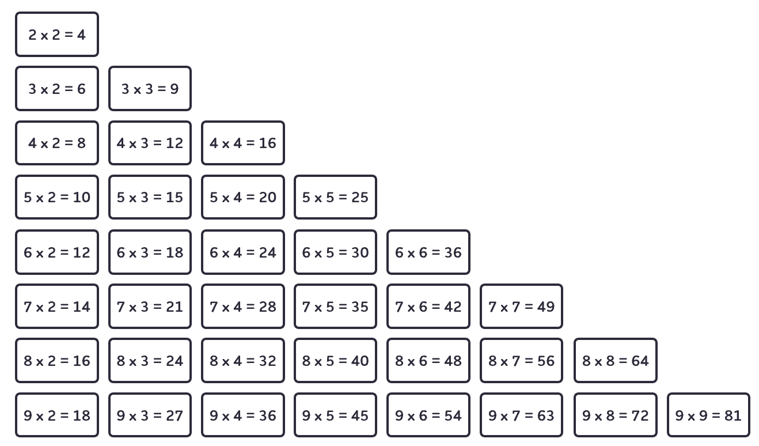
Children learn the facts a bit like song lyrics. We want them to be so comfortable saying the facts that they trip off the children’s tongues – a bit like singing along to a song without having to really think about the words at all.
We have a daily 10 minute times table session.
- We learn a small number of new facts at a time- just two or three – and practice until we are really confident.
- Alongside these new facts, we keep practising facts we know already
- We practise until we are really quick and confident.
Each child has their own booklet in which we aim to complete 40 facts. After this, the teacher chants each fact and the children chant it back. This saying of the facts out loud, and the practise trying to recall the facts and write them in the booklet, is what leads to memorisation.
We have a display up in the class showing all our times tables facts. If we haven’t learnt a fact yet the children copy it off the display. But over time, after saying each fact lots of time, the children will remember them as a sound pattern and no longer need to copy off the display.
As part of the approach, children learn to apply their memorised fact to all facts in the fact family. For example we memorise “seven fives are thirty-five” and then children have lots of practice applying that to 5 x 7, 35 ÷ 5 and 35 ÷ 7. The children will get really confident moving between multiplication and division.

In Year 3 we learn 21 of the 36 essential facts
2 times table | Square times table | 5 times table
8 facts | 7 new facts | 6 new facts
2 x 2 = 4  3 x 2 = 6  4 x 2 = 8  5 x 2 = 10  6 x 2 = 12  7 x 2 = 14  8 x 2 = 16  9 x 2 = 18 | 3 x 3 = 9  4 x 4 = 16  5 x 5 = 25  6 x 6 = 36  7 x 7 = 49  8 x 8 = 64  9 x 9 = 81 | 3 x 5 = 15  4 x 5 = 20  6 x 5 = 30  7 x 5 = 35  8 x 5 = 40  9 x 5 = 45

What if my child needs additional help?
Because the programme is so well structured and builds up the new facts in such small groups, most children, including children with SEND, will learn their facts just through the daily sessions. We monitor how children are getting on in the sessions on a daily basis, and intervene very quickly if we think any of the new facts are not sticking as quickly as we would like. Our aim is to stop gaps opening, rather than ‘play catch up’ once gaps have already opened. The vast majority of support happens within our 10 minute daily sessions. This might simply be through asking a child to identify one a target fact which they can practice several times that day for example. Occasionally, we may put some additional support in place outside the session, for example providing children with a pack of times tables cards that they can self-quiz on a couple of times a day.

How can I help at home?
- Show an interest in how your child is getting on. Ask them what times table we are learning currently. Ask them which the new facts are in that times table, and if there are any particular facts they have just learnt to recall. Prompt your child to say this fact a few times.
- Celebrate your child’s successes. We work up to all children recalling 40 facts so you can ask your child how they are getting on, or something they are particularly proud of. Sometimes we will prompt the children to go home and tell you how well they have done, so if your child does this do take the time to tell them how proud you are. Self-confidence and motivation is so helpful in learning times tables!
- If your child is trying to recall a times table they have already been taught, prompt them to read it out loud. For example, if a child saw 7 x 5 written down, prompt them to say “Seven fives….” out loud. This prompts the sound memory: “Seven fives are…thirty five.” We learn each sound pattern with the larger factor first, so if your child say 5 x 7 written down, we would still say that as “Seven fives…”. The children will become very confident changing the order of the factors in this way when they read a calculation out loud.

Any questions please feel free to ask us.
The Year 3 Team

