As authors we have been looking at inverted commas (speech marks).

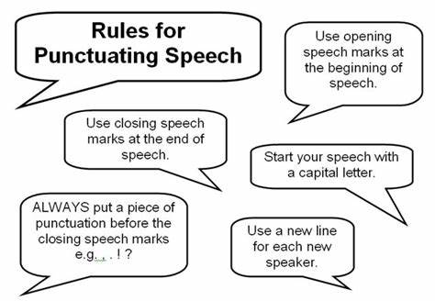

Copy out the following sentences in your best handwriting, adding in the inverted commas and correct punctuation.

