Diwali

In RaW we have been finding out about Diwali.

The word Diwali means 'rows of lighted lamps'. It is celebrated by Hindu people across the world.

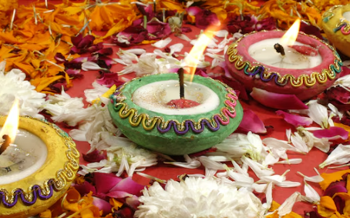

Diwali is known as the 'festival of lights' because houses, shops and public places are decorated with small oil lamps called 'diyas'.

Do some research on Diwali. How can you share it with us?

Ideas:

* Make a booklet
* Create a picture
* Make a PowerPoint
* Make a poster
* Create a Rangoli pattern
* Comic strip of the story of Rama and Sita

Useful websites

<https://www.bbc.co.uk/bitesize/articles/zjpp92p#z6nnkhv>

<https://kids.nationalgeographic.com/pages/article/diwali>

Bring in what you have created.