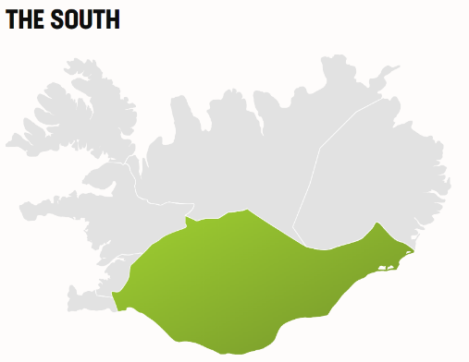Iceland is a country full of geological contrasts and they are best visible in the South, where geothermal heat meets glacial cold. In the Southwest and the Golden Circle Area, the heat is on, providing the energy for Iceland’s many greenhouses and swimming pools. The Southeast shows off Europe’s biggest glacier Vatnajökull, spectacular waterfalls, and black sand beaches on which the powerful waves of the North Atlantic break.

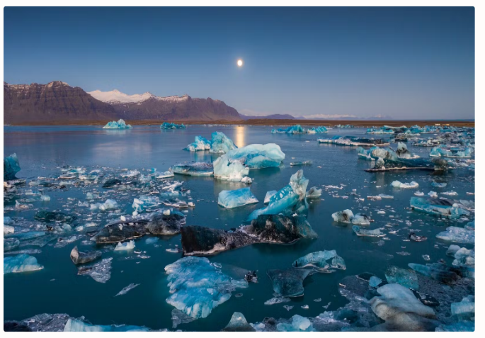**SOME HIGhLIGHTs IN THE SOUTH**

**Most famous sights:** Geysir, Gullfoss, Seljalandsfoss, Skógafoss, Dyrholaey, Reynisfjara Black Sand Beach, Skaftafelll, Jökulsárlón, Diamond Beach, Vestrarhorn

**National Parks:** [Þingvellir National Park](https://www.visiticeland.com/article/thingvellir" \t "_blank)**,**[Vatnajökull National Park](https://www.visiticeland.com/article/vatnajokull" \t "_blank)

**Scenic Routes:** [Golden Circle](https://www.visiticeland.com/article/the-golden-circle)**,**[South Coast](https://www.visiticeland.com/article/the-south-coast)**,**[The South Coast Lighthouse Trail](https://www.south.is/en/destinations/towns-regions/the-south-coast-lighthouse-trail)

**Culinary specialties of the South**: craft beers, local vegetables, langoustines, and seafood.

**How to get there:**From Reykjavík it's 30-40 minutes to the westside of South Iceland and the Golden Circle.

From Keflavik, it's only 30 minutes to the South Coast Way (Suðurstrandavegur) No.427.

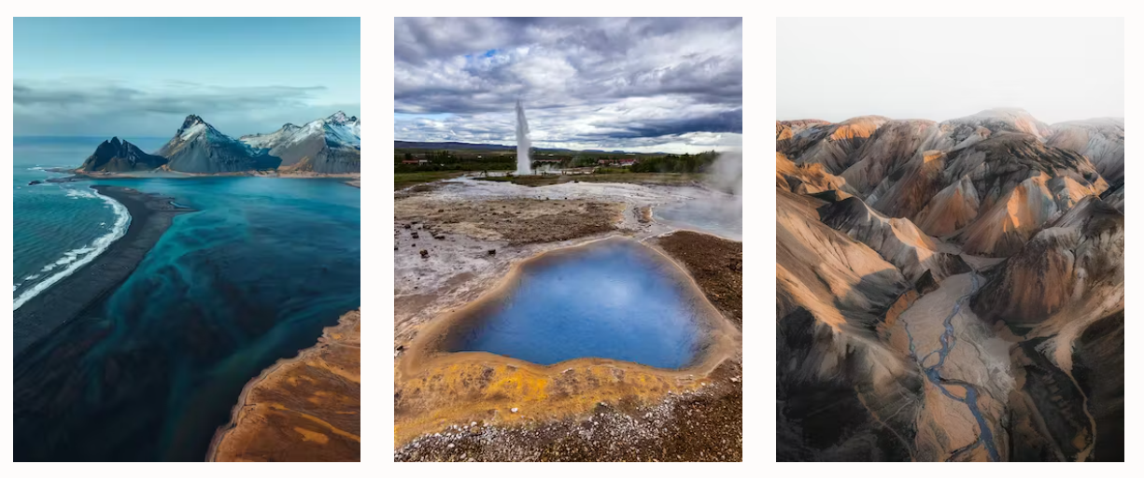

#### **THE HEAT IS ON - GEOTHERMAL POWERS OF THE SOUTH**

Geothermal activity is high in the southwest of Iceland and especially in the Golden Circle Area where it powers the garden of Iceland. With 126.000 m3 and more than 66% percent of the national greenhouse acreage, the South is the area of Iceland that produces the most vegetables in the country.

Local milk and meat produce combined with vegetables from Flúðir, Hverargerði, Reykholt and Iceland’s potato town Þykkvabær make the southern kitchen a uniquely local one. Tasting local produce is also possible in some of the greenhouses of the South.

#### LOCAL SPECIALTIES ALL YEAR-ROUND

With most of the country's agricultural products coming from the area, the South is a fine testimony to Icelandic restaurant culture. Enjoy the locally grown vegetables in combination with freshly caught fish of the day and the South’s seafood specialty langoustine in all its variety and deliciousness!

To top it off, you can find out, what the local breweries have to offer and taste fine Icelandic craft beers by Ölverk, Smiðjan Brugghús, Ölvisholt Brewery, and Brothers Brewery.

#### HOT SPRINGS AND SWIMMING POOLS

Feel the heat and bathe in hot springs and spas fed with water by mother earth!

Few experiences are as relaxing as taking a dip in one of many local [swimming pools](https://www.south.is/en/experiences/bathing-wellness/swimming-pools)or the geothermal baths Secret Lagoon and Laugarvatn Fontana.Natural Hot Pots can among others be found in the Reykjadalur valley and Landmannalaugar nature reserve.

The [Katla UNESCO Global Geopark](https://www.katlageopark.com/" \t "_blank) includes an area of 9542m2 and more than 20 breathtaking sites along the south to the southeastern coast. Within the GeoPark, different trails can be found, amongst them a waterfall and geology trail.The famous Great Geysir, the geyser Strokkur and various kinds of hot springs, fumaroles, and sulfurous mud pots can be explored [at the Geysir geothermal area](https://www.south.is/en/destinations/nature/geothermal-areas/geysir-geothermal-area). At the [Geothermal Park in Hverargerði](https://www.south.is/en/destinations/nature/geothermal-areas/geothermal-area-in-hveragerdi), the geothermal springs are used for cooking and baking and everyone can take part!At the [Laugarvatn Fontana](https://www.fontana.is/en" \t "_blank) one can taste bread baked by geothermal heat and dip into hot pools  In what other ways and the technical background on how we put all that energy to use is explained in the [Hellisheiði Geothermal power plant and exhibition.](https://www.south.is/en/service/on-geothermal-exhibition-at-hellisheidarvirkjun" \t "_blank)The [Reykjadalur Valley](https://www.south.is/en/destinations/nature/geothermal-areas/reykjadalur-valley" \t "_blank) close to the Golden Circe is a beautiful hiking area with lots of hot springs, that invite you to take a bath in nature! A trip further into the interior of Iceland is required to hike in the [Kerlingafjöll mountains](https://www.south.is/en/destinations/nature/the-highlands/kerlingarfjoll-mountains" \t "_blank), one of Europe’s largest geothermal areas.

**WATERFALLS, BEACHES & GLACIERS – COOL, COOLER, COOLEST**

#### WATERFALLS

It is impossible to tell, how many “fosses” there are in Iceland, but the South sure has some of the most spectacular ones!

Besides Gullfoss in the Golden Circle and Svartifoss in Skaftafell National Park, the famous waterfalls Skógafoss, Seljalandsfoss and Gljúfrabúi are lined up on your way further east along the ring road.

But why only stop there? on the south coast of Iceland, beautiful surprises waits for those who [hunt for the lesser-known waterfalls](https://www.south.is/en/destinations/towns-regions/katla-geopark-vestmannaeyjar/travel-ideas/the-waterfalls-of-the-geopark)**.**

#### BEACHES

Upon the 120-meter-high promontory Dyrholaey, one has a stunning view over black sand beaches to left and right as well as over to the famous Reynisdrangar sea stacks. They mark the face of the Vík area, where one can walk on the impressive black sand beach of Reynisfjara beach with its impressive basalt columns and volcano Katla in the background.

Though the powerful waves are monumental to look at, treacherous undercurrents can become dangerous when getting too close to the freezingly cold water. Reynisfjara beach is especially dangerous and has claimed the lives of visitors as well as the Kirkjufjara beach at Dyrholaey.

[Here you can find out how to stay safe](https://www.visiticeland.com/article/reynisfjara-black-sand-beach-is-dangerous)

#### GLACIERS

Ice climbing, ice cave tours, glacier walks: the range of ice connected activities is huge!

[Boat and kayak tours](https://www.ferdalag.is/en/activities/nature/jeep-glacier-tours)navigate between small icebergs at the Fjallsárlón and Jökulsárlón glacier lagoons.On Diamond beach at Breiðarmerkursandur, chunks of glacial ice washed up the black sand beach make for dreamlike photo motifs.

#### HIKING

[Vatnajökull National Park](https://www.vatnajokulsthjodgardur.is/en/plan-your-visit/basic-information/hiking)encompasses Skaftafell with magnificent views on the glacier in the south-east and Jökulsárgljúfur in the north as well as all of the Vatnajökull glacier, including Iceland‘s highest peak Hvannadalshnjúkur. In its vicinity, one can find stunningly beautiful hiking areas.